Operating System Lab 4

Muhammad Adil Saeed | 24k-0705
Question 1:
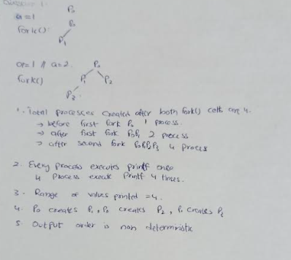

Question 2:
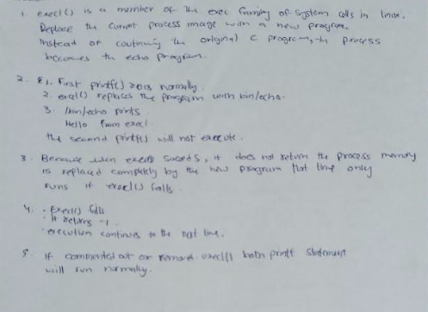

Question 3:
Marks.c:
#include <stdio.h>
#include <stdlib.h>
#include <unistd.h>
#include <fcntl.h>
#include <string.h>
int main() {
int fd;
int marks[5];
char buffer[100];
int total = 0;
fd = open("marks.txt", O_CREAT | O_WRONLY | O_TRUNC, 0644);
if (fd < 0) {
perror("Error creating file");
exit(1);
}
printf("Enter marks for 5 subjects:\n");
for (int i = 0; i < 5; i++) {
printf("Subject %d: ", i + 1);
scanf("%d", &marks[i]);
sprintf(buffer, "%d\n", marks[i]);
write(fd, buffer, strlen(buffer));
}
close(fd);
fd = open("marks.txt", O_RDONLY);
if (fd < 0) {
perror("Error opening file");
exit(1);
}
char readBuffer[100];
int bytesRead = read(fd, readBuffer, sizeof(readBuffer) - 1);
if (bytesRead < 0) {
perror("Error reading file");
close(fd);
exit(1);
}
readBuffer[bytesRead] = '\0';
char *token = strtok(readBuffer, "\n");
while (token != NULL) {
total += atoi(token);
token = strtok(NULL, "\n");
}
printf("\nTotal Marks = %d\n", total);
close(fd);
return 0;
}
Marks.txt:
15
32
54
13
67

Terminal:
